Drumming Circle 2020 Schedule

Join us in the sacred ceremony of sacred drumming
2ND FRIDAY On the following dates from
7:00-8:30 pm

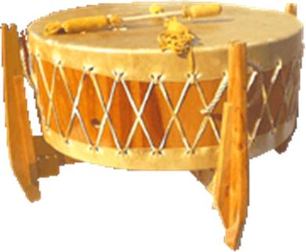

2020 SCHEDULE

January 10 July 10
February 14 August 14
March 13 September 11
April 10 October 9
May 8 November 13
June 12 December 11

